**Change the Volume Size of an Instance**

**Step 3.2.1:** Creating the new volume which we want to add to an instance and clicking on **create volume**

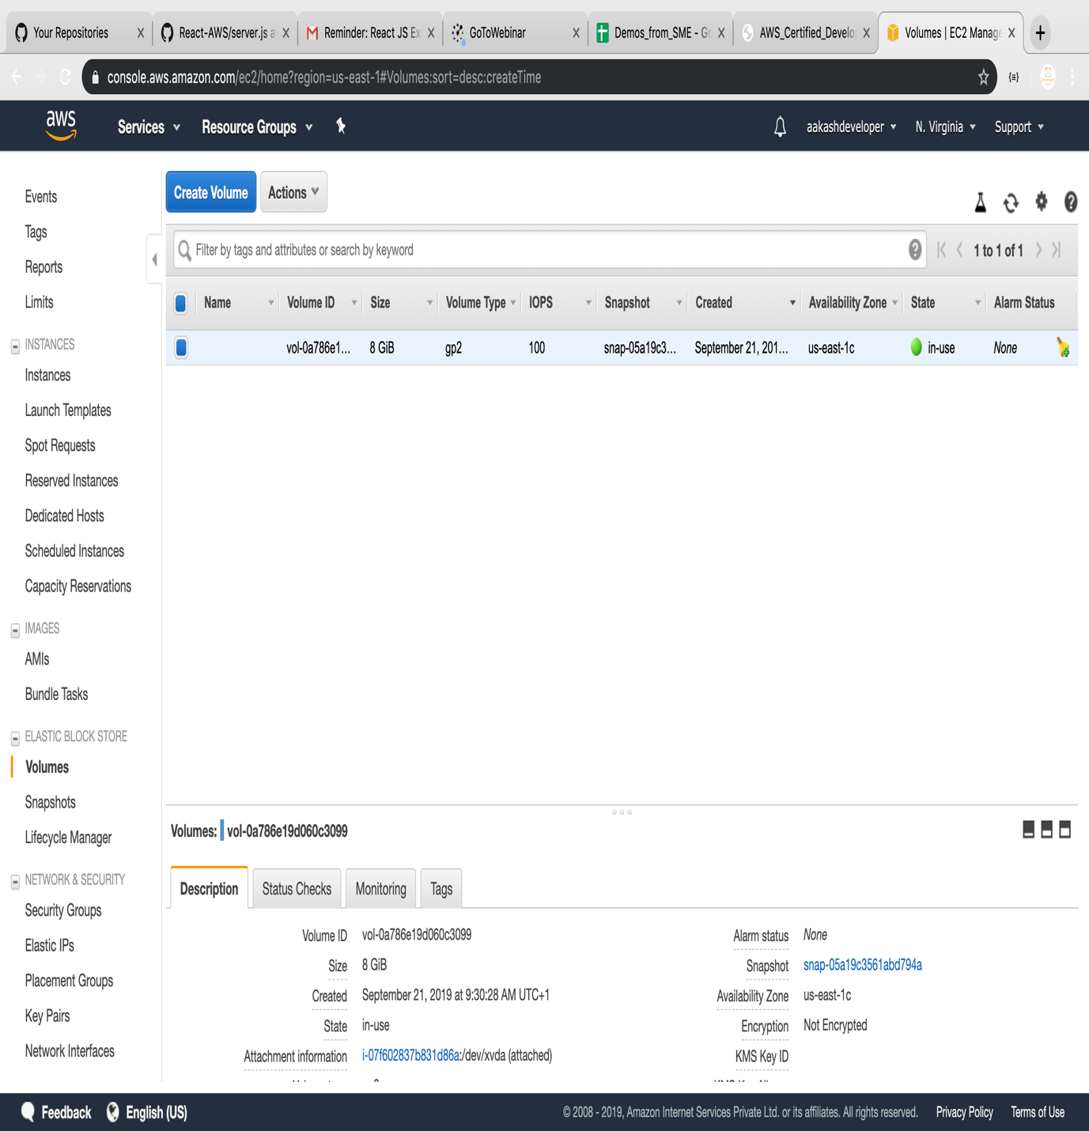

**Step 3.2.2:** Validating the Availability zone of the EC2 instance with which you want to add volume

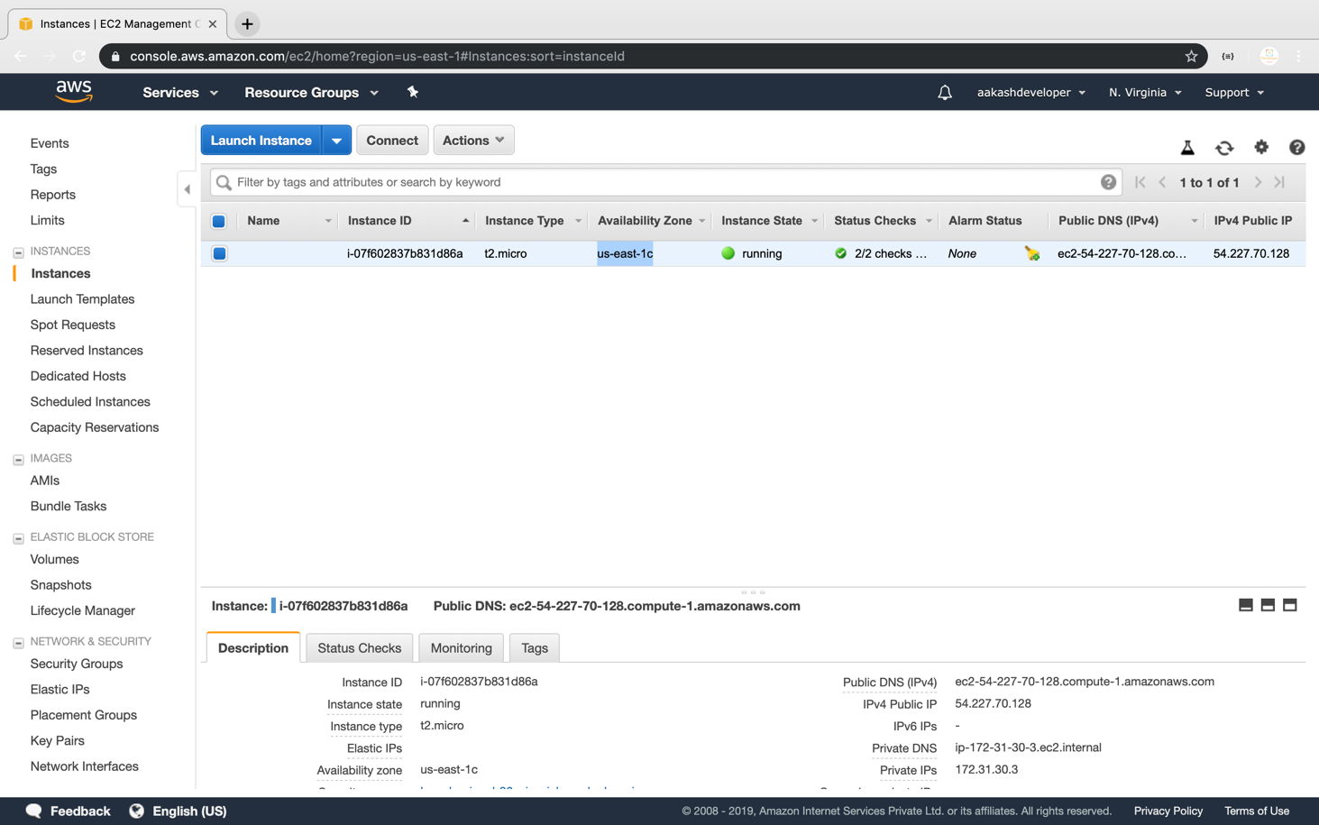

**Step 3.2.3:** Providing type, size, availability zone, and snapshot name on the **create volume** tab

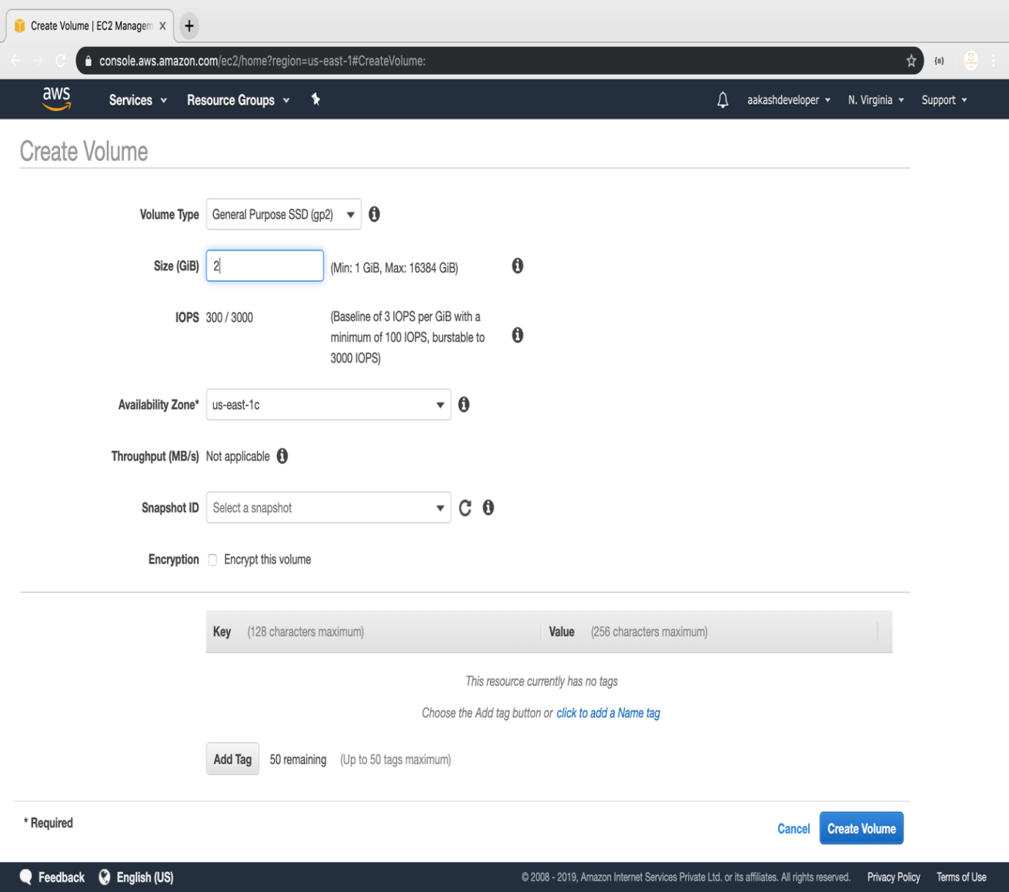

**Step 3.2.4:** Selecting newly created volume and clicking on the action to attach the volume to the instance

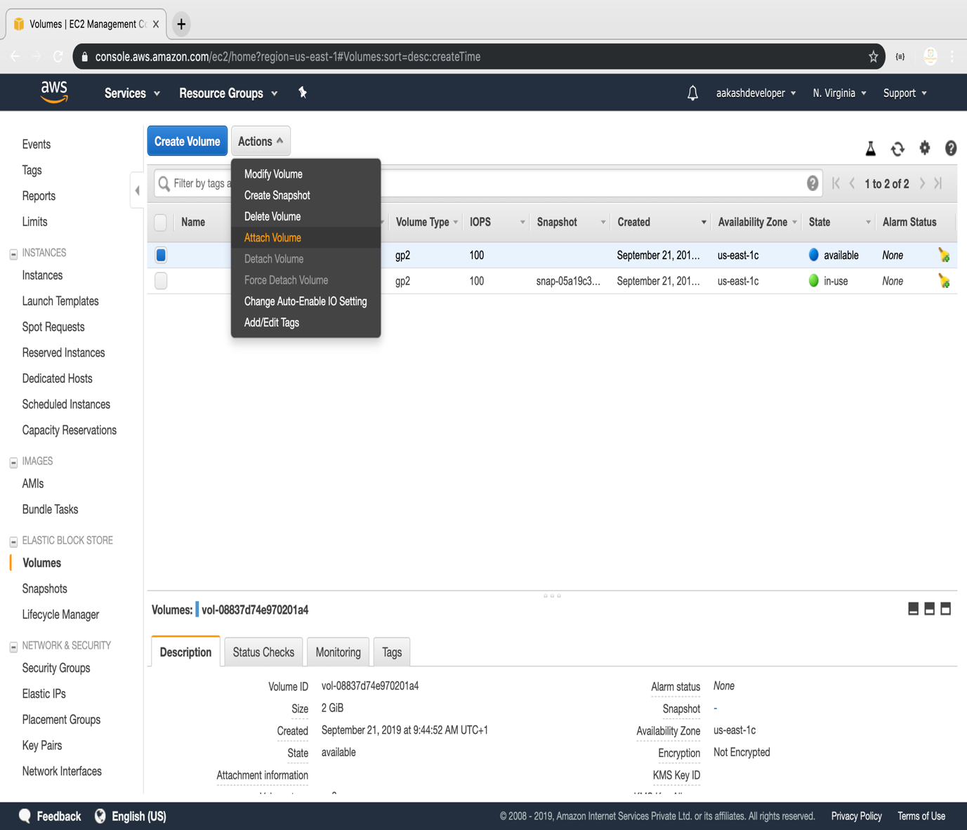

**Step 3.2.5:** Selecting the instance of the same availability zone and attaching the volume in pop

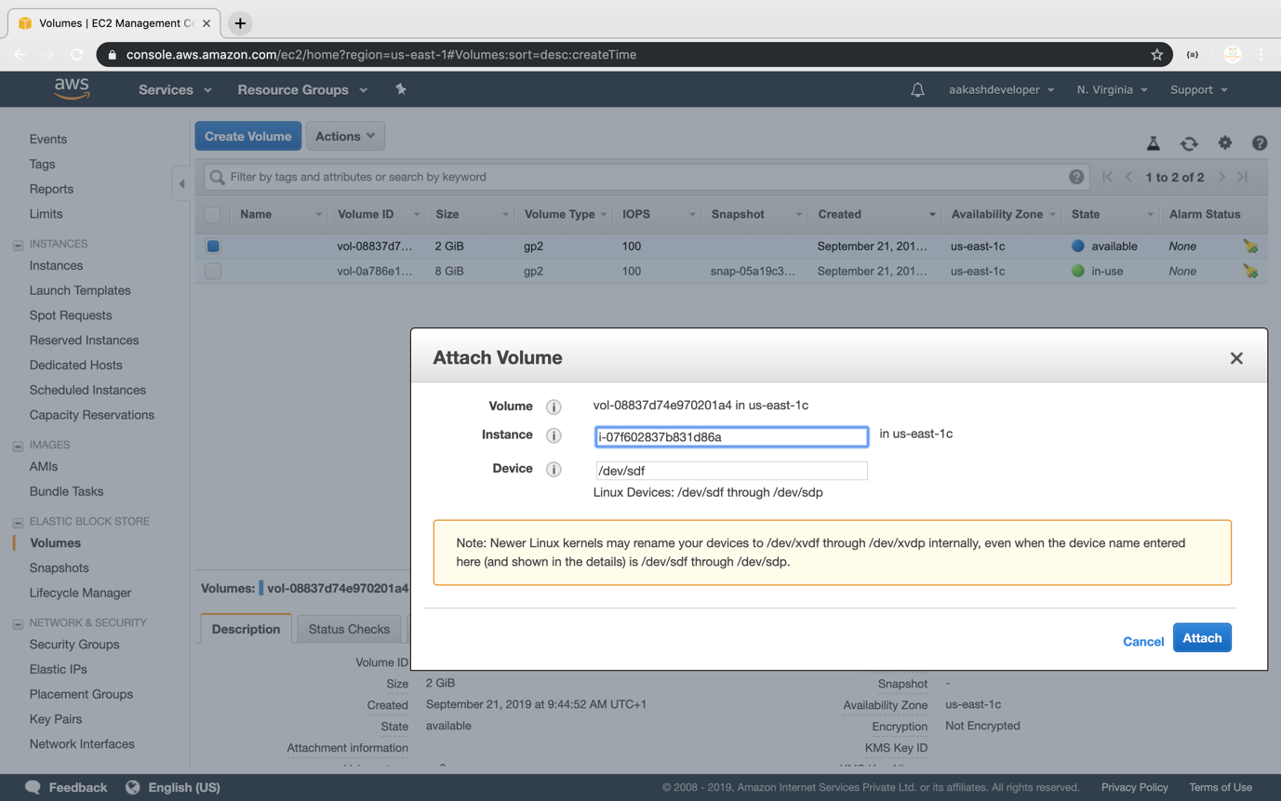

**Step 3.2.6:** Verifying the instance by adding one more device to the block device

